**[F29DC 2024 Lab 4 –](https://canvas.hw.ac.uk/courses/28951/files/3694381?wrap=1" \o "F29DC 2024 Lab 1 - Connectivity, VPCs, Subnets, VLANs.pdf" \t "_blank) DHCP and NAT  
- Shyam Sundar Velmurugan  
- H00418621**

{Part 1}

Topology configuration

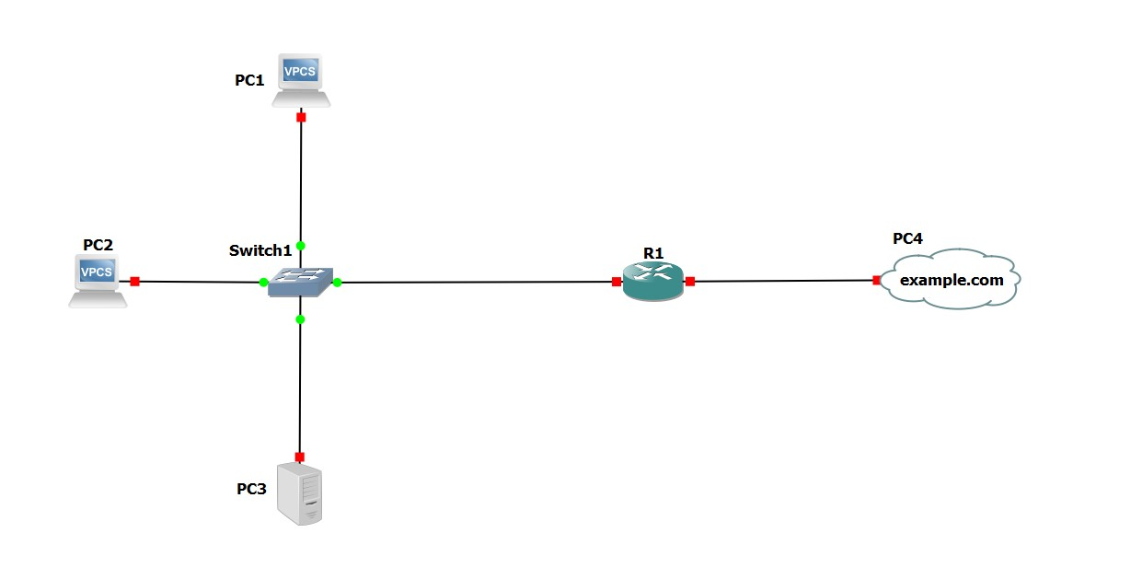

Image 1.1 : Setting up connections between PC1, PC2, PC3,PC4, Switch, R1 .

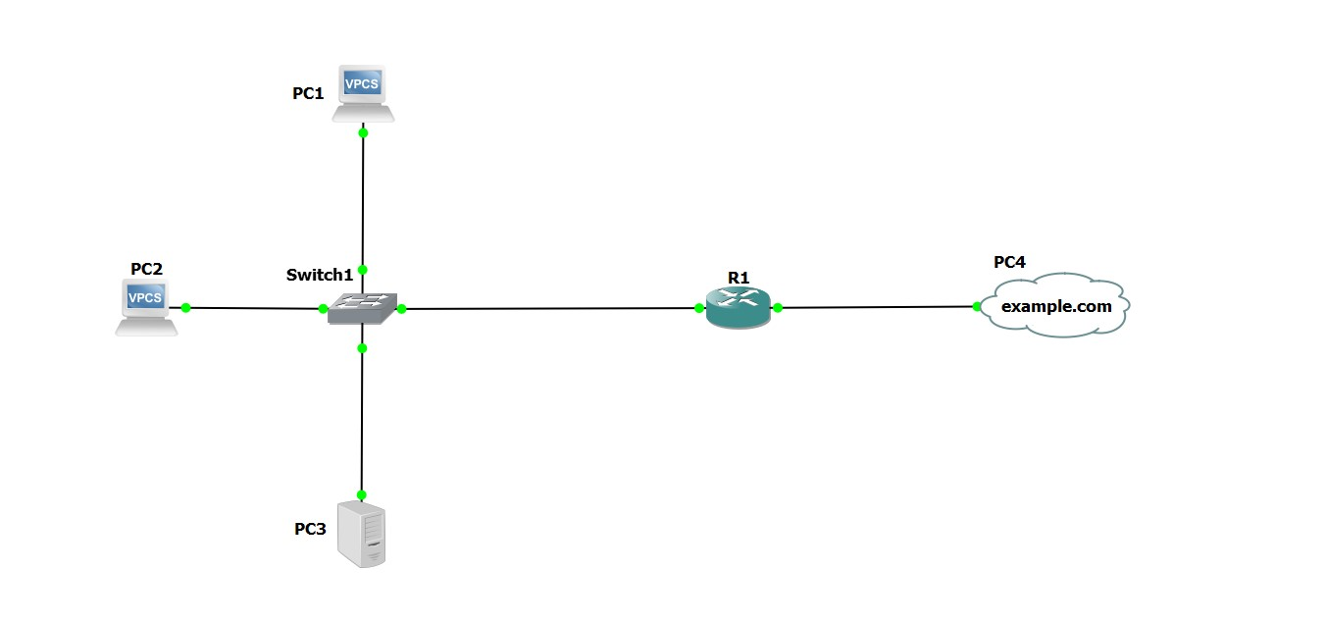

Image 1.2 : Starting all the connections.

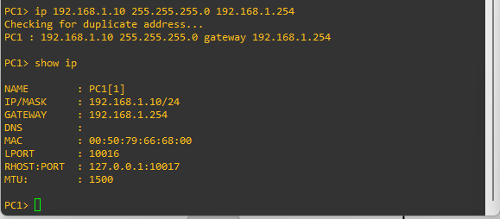

Image 1.3 : Providing the IP address for PC1 with the gateway and also showing the ip.

Ip 192.168.1.10 255.255.255.0 192.168.1.254

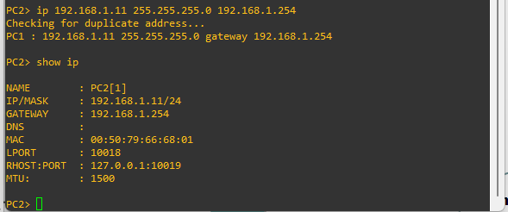

Image 1.4 : Providing the IP address for PC2 with the gateway and also showing the ip.

Ip 192.168.1.11 255.255.255.0 192.168.1.254

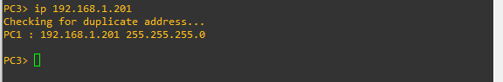

Image 1.5 : Providing the IP address for PC3

Ip 192.168.1.201

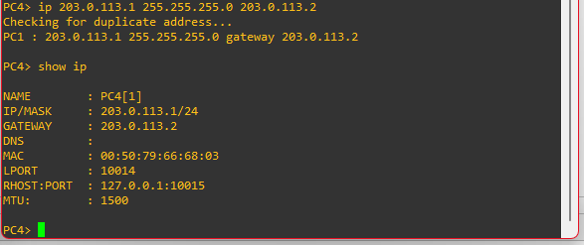

Image 1.6 : Providing the IP address for PC4 with the gateway and also showing the ip.

Ip 203.0.113.1 255.255.255.0 203.0.113.2

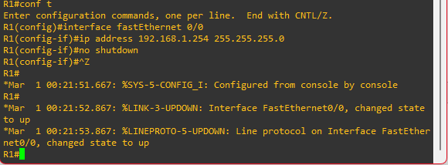

Image 1.7 : Setting up R1 router with fast Ethernet 0/0 with ip address 192.168.1.254 255.255.255.0.

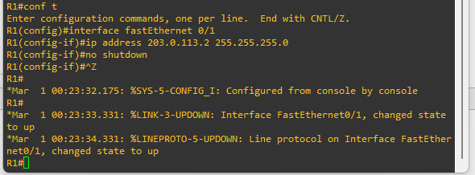

Image 1.8 : Setting up R1 router with fastEthernet 0/1 with ip address 203.0.113.2 255.255.255.0.

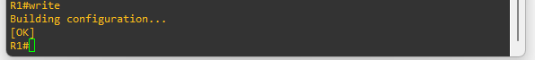

Image 1.9 : Using the write command to save the ip configuration of R1 router.

------------------------------------------------------------------------------------------------------------------------------------------